# CS 255 Business Requirements Document Template

Complete this template by replacing the bracketed text with the relevant information.

This template lays out all the different sections that you need to complete for Project One. Each section has guiding questions to prompt your thinking. These questions are meant to guide your initial responses to each area. You are encouraged to go beyond these questions using what you have learned in your readings. You will need to continually reference the interview transcript as you work to make sure that you are addressing your client's needs. There is no required length for the final document. Instead, the goal is to complete each section based on your client's needs.

**Tip:** You should respond in a bulleted list for each section. This will make your thoughts easier to reference when you move into the design phase for Project Two. One starter bullet has been provided for you in each section, but you will need to add more.

## System Components and Design

### Purpose

*What is the purpose of this project? Who is the client and what do they want their system to be able to do?*

DriverPass is one of our clients, and they want to take advantage of a void in the market when it comes to training students for driving tests at their local motor and vehicle department (DMV). *Based* on Liam, Ian (personal communication, January 22,2021)*, Driverpass* wants to provide students with access to online practice exams and on-road training to better prepare them for driving tests.

### System Background

*What does DriverPass want the system to do? What is the problem they want to fix? What are the different components needed for this system?*

* According to Liam, Ian (personal communication, January 22,2021), DriverPass asked us to build a system that works on a cloud and is connected to the local Motor and vehicle division (DMV).
* While the system handles all user's accounts and privileges, it will consist of managing customer's appointments for driving lessons online and on-site. The system must be accessible from any device and everywhere.
* The components are the students, the drivers, Driverpass employees, and the cloud infrastructure.

### Objectives and Goals

*What should this system be able to do when it is completed? What measurable tasks need to be included in the system design to achieve this?*

*Based* on Liam, Ian (personal communication, January 22, 2021)*, the system will provide the following function:*

* Be accessible from anywhere and from any device for the users
* Download report, reset, and block password
* Reset customer's password automatically
* Define right and roles for each user
* Allows users to track the reservations, create, modify and cancel them
* Create users account and register customers
* Allows customers to make an online reservation for driving lessons.
* Schedule online/on-site appointment for a driving lesson, modify and cancel them
* Enable/ Disable packages
* Automatically receive DMV's notification on new rules, policies, sample questions and update them
* It should display a page with online test status, driver notes and photo, customer information, photo start time and end time, lesson time, and the company logo.
* It should display a page to contact a student and a page to contact the company

## Requirements

Based on Liam, Ian (personal communication, January 22nd ), we will review the different nonfunctional requirements and the functional requirements for the Driverpass system.

### Nonfunctional Requirements

#### Performance Requirements

*What environments (web-based, application, etc.) does this system need to run in? How fast should the system run? How often should the system be updated?*

DriverPass does not want to deal with security and backup. They want the system to be a cross-platform system that runs on the cloud. The system must run fast enough for the critical processes. It should give feedback to the customers who are verifying their progress in less than one second—the same thing for customers who are loading their appointment information.

#### Platform Constraints

*What platforms (Windows, Unix, etc.) should the system run on? Does the back end require any tools, such as a database, to support this application?*

DriverPass wants the system to be able to identify the driver the customer is scheduled to go out with; the owner wants to query the system to have some reports and data. Therefore the back end will require a server and a database to support the application, which the cloud company will provide. Because the system must be accessible from any device, the system should run on multi-platforms (Windows, Unix, macOS, Android, iOS, Web browser, HTTP, etc.)

#### Accuracy and Precision

*How will you distinguish between different users?* *Is the input case-sensitive? When should the system inform the admin of a problem?*

The system will have two types of users, the employees, and the customers. Each user will have an account with a unique case-sensitive password. The format of the employee's username must be their last name dot their first name underscore role. For example, if the manager's name is Smith Liam, the corresponding username must be Liam.Smith_manager .The employees, based on their roles, will have different privileges and rights. The system informs the admin of a problem when:

* Users having trouble logging in (multiple attempts)
* Users are unable to connect to the platform
* The servers are down
* Users are not able to download or print the reports

#### Adaptability

*Can you make changes to the user (add/remove/modify) without changing code? How will the system adapt to platform updates? What type of access does the IT admin need?*

The system should adapt to platform updates by keeping all the resources and nonfunctional requirements update in the source code. As requested by Driverpass the IT admin must maintain the system. Thus, the IT admin should have all privileges and be able to add, remove or modify users without changing the code. The IT admin must update the database table of driving lesson with DMV new content

#### Security

*What is required for the user to log in? How can you secure the connection or the data exchange between the client and the server? What should happen to the account if there is a “brute force” hacking attempt? What happens if the user forgets their password?*

The users will need a username and password to log in. The combination of encrypted passwords and a one-time strong password (letters, numbers, and symbols) secure the authentification. The users will automatically reset their password after answering multiple authentication questions. Because of their privileges and rights, employees' accounts must be reset by the IT manager. The network system should have a computer and a router that sits between trusted and untrusted firewalls. The system administrator must implement a lockout policy and progressive delays to prevent "brute force." In case there is a brute force attempt, the system must send a notification to the user's email address and phone number. Customer payment information will be encrypted using standard encryption and decryption algorithms on the market to secure data transmission over a public network.

### Functional Requirements

*Using the information from the scenario, think about the different functions the system needs to provide. Each of your bullets should start with “The system shall . . .” For example, one functional requirement might be, “The system shall validate user credentials when logging in.”*

* The system shall validate user credentials when logging in
* The system shall create a user account
* The system shall allow the IT officer to reset the Management employee's account and block access
* The system shall allow the user to reset their password automatically.
* The system shall download and print user data and activity report
* The system shall make, modify and cancel online student appointment for driving lessons
* The system shall schedule, modify and cancel one site user appointment for driving lessons
* The system shall identify an assigned driver for each driving lessons
* The system shall match up driver, car, and date to a student
* The system shall record customer registration information
* The system shall create, modify and disable student packages
* The system shall register the student for a package
* The system shall notify the administrator of all DMV updates policies and news
* The system shall display to the user the training dashboard (interface)
* The system shall display to the user the online test status
* The system shall allow the driver to enter a note
* The system shall display to a user a form to contact the student
* The system shall display to a student a form to contact Driverpass

### User Interface

*What are the needs of the interface? Who are the different users for this interface? What will each user need to be able to do through the interface? How will the user interact with the interface (mobile, browser, etc.)?*

According to Liam, Ian (personal communication, January 22, 2021), the system must provide a dashboard training interface for the customer to verify their progress and consult driver notes. Through other interfaces, the customers must have the possibility to set up, cancel and modify an appointment and access their schedules(date, time, driver photo, student photo, special needs). The owner interface must access and print multiple reporting activities such as listing employees who cancel or modify appointments, the list of upcoming training sessions, and listing the new account. The IT manager interface will allow him to create and modify rights and privileges for each user, access log files, and reset the user's account. Driverpass secretary's interface must create and modify an appointment. All the resources are accessible from any device ( desktop and mobile devices).

### Assumptions

*What things were not specifically addressed in your design above? What assumptions are you making in your design about the users or the technology they have?*

Base on Liam, Ian (personal communication, January 22, 2021)

* The cloud servers are running 24/7 with backup
* Internet and electricity are available for all users 24/7
* All users can make use of smartphones, tablets, laptops, and computers

### Limitations

*Any system you build will naturally have limitations. What limitations do you see in your system design? What limitations do you have as far as resources, time, budget, or technology?*

Based on Liam, Ian (personal communication, January 22, 2021)

* The system will not run or stop running if cloud servers are unavailable
* The system will not run if the internet or electricity is lost
* Screen size when using a browser on a smartphone compared to desktops or laptops
* Phones do not have enough power compared to desktops and laptops
* Some browsers impact battery life than others.
* budget

### Gantt Chart

*Please include a screenshot of the GANTT chart that you created with Lucidchart. Be sure to check that it meets the plan described by the characters in the interview*

*Based on* Liam, Ian (personal communication, January 22, 2021)

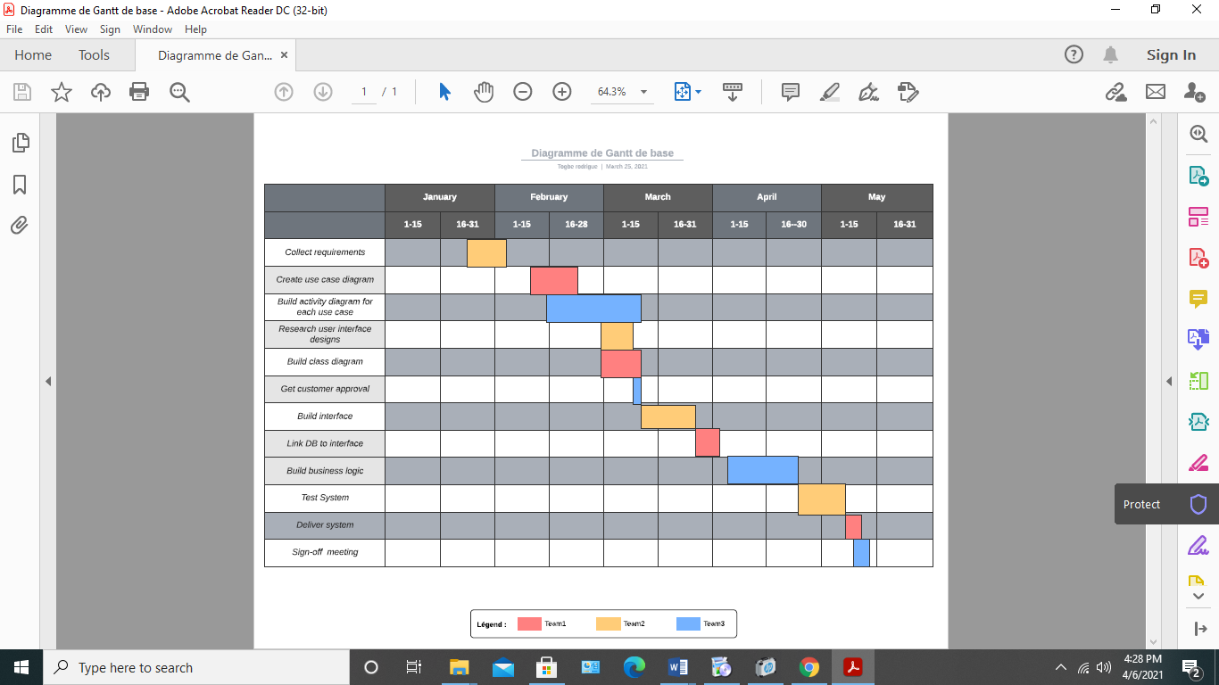

References:

What is a brute Force: Common tools & Attack Prevention: Imperva. (2020, July 07th). Retrieved April 13th, 2021, from https://www.imperva.com/learn/application-security/brute-force-attack/

Ung, G. (2016, June 27th). Which browser is best for battery life: We test edge vs. Chrome vs. Opera vs. Firefox. Retrieved April 13th, 2021, from https://www.pcworld.com/article/3087338/which-browser-is-best-on-battery-we-test-edge-vs-chrome-vs-opera-vs-firefox.html